Game Logic: Our game is a web based interactive learning and teaching game for undergraduate software engineering students. The game has a real time synchronized system where a Host (Lecturer) manages the session. The host is responsible for the questions and flow of the game. Our game allows a classroom, a group of people or organizations to make the learning process in a fun way. Our game features flexible access to the system. The platform has Registered Users and Guests. This technique of design helps people to easily reach the platform and spectate ongoing games. Only Registered Users have privilege to host a session or join an active game. This ensures the competitive data and hosting responsibilities are tied to verified users, while the spectating users have right to learn from ongoing games. Joining game has 2 options first one is with QR code, and the second one is a unique session link provided by the host. Once the game starts, players are presented with questions related to software design patterns, each question has 4 distinct choices. The scoring system is based on accuracy and timing. Each correct answer grants points to the player. Competition is supported with a real time leaderboard including the players ranking and score, at the end of the game the leaderboard is presented to everyone.
Name of the Game: Design Dash
Type of the Game: Web
USE CASE DIAGRAM:
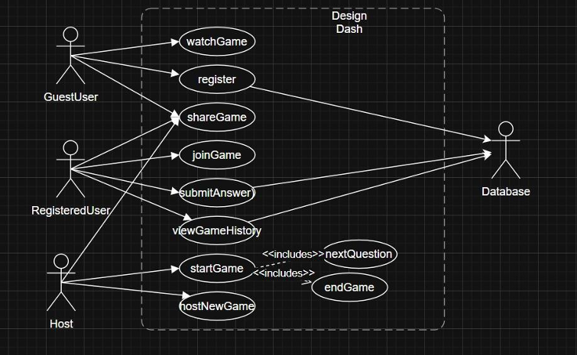
CLASS DIAGRAM:
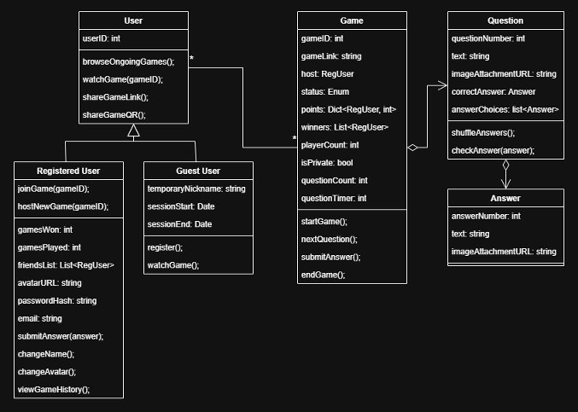
SEQUANCE DIAGRAM:
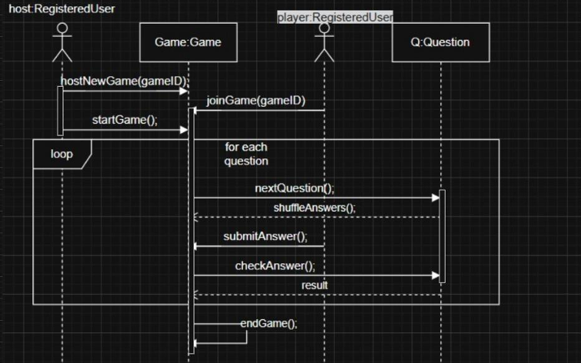
ACTIVITY DIAGRAM:
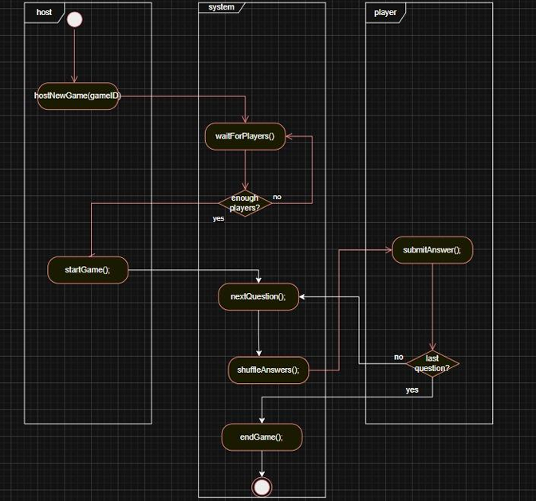

STATE DIAGRAM:
